**Term Project Report**

Team Lee Shin

20131329 신선우, 20141440 이승원

**Q1. Five Typical Pattern of employees**

You can see the graph on the following link.

<https://github.com/Sunny8747/UNIST_InfoVis/blob/master/VAST_Challenge_2016_MC2/d3gantt_original.html>

You can use the x-axis and y-axis scrollbar to navigate through the graph. If the mouse is on the graph, the tooltip box shows the information of that time. “Task” means the location of employee (mFnZ means m’th floor n zone), “Type” means the proxy ID of employee, “Starts” and “Ends” means the entering time and exiting time respectively. Each location is distinguished by color.

**Pattern 1)** Most employees go to work at 7am to 8am and leave work around 5pm

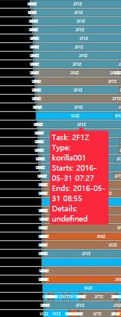 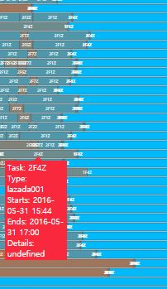

Except for the late shift members, most employees go to work between 7am to 8am. It can be inferred that the commuting time of the company is up to 8am. They leave work around 5pm. They do not go to work at the weekend.

**Pattern 2)** Most employees have lunch from 12pm to 1pm

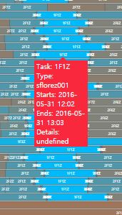

Most of employees pass through 1F1Z at 12pm and 1pm. Because that zone is the entrance of the building, we can guess that they exit the building to have lunch at that time. In addition, we can also infer that the company gives an hour for lunch break.

**Pattern 3)** Late shift workers of IT and Facilities department go to work around 4pm and leave work at midnight

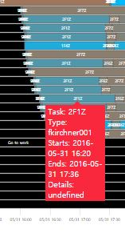 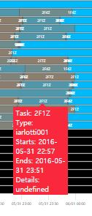

Late shift members go to work around 4pm. Most of them are from IT or Facilities department. Most of the late shift workers leave work at midnight. Based on the preceding patterns, we can figure out that the late shift workers work 8 hours (4pm to midnight), while day shift workers work 9 hours (8pm to 17pm).

**Pattern 4)** Two employees from Facilities department work during dawn

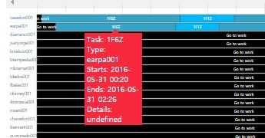 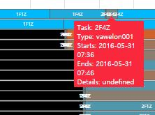

Two members of the Facilities department work during dawn. They start to work at midnight and leave work at around 7pm. We can infer that the company deploys two workers at dawn.

**Pattern 5)** Two employees from the Facilities department who work during dawn are usually at Deli and one of them always leave work later than the other.

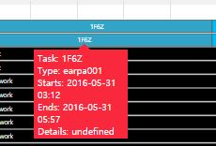 

Most of the time, they are at 1F6Z. Since 1F6Z means first floor zone 6 (1060), which is Deli, we can figure out that they usually are at Deli. We can also find an interesting pattern that one of two workers always leave work later than the other. Since he or she visits many places in a short time, it seems that the worker checks the other zones before leaving work.

**Q2. Five Interesting Patterns of building data**

You can see the implementation on the following link.

<https://sunny8747.github.io/UNIST_InfoVis/VAST_Challenge_2016_MC2/building_line_chart.html>

In the main page, you can see the building layout of the company. Graphs are implemented in the second tab “Building Data AND Hazium”. It may not work at first, so please try to refresh the page if you cannot see any graph or only one graph in the second tab. The x-axis represents the sequential time, and because all graphs have the same interval for the x-axis, you can easily compare the values of the same time. The y-axis represents each value of the building data. The pink area represents the weekend. When the mouse is on the graph, the tooltip box shows the values at that time. If you want to see only specific data, you can remove other data by clicking the index under the title of each graph.

**Pattern 1)** Fluctuation during weekday

Light&Equipment Power Temperature Data VAV reheat damper position

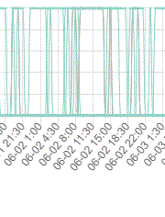 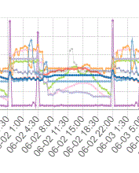 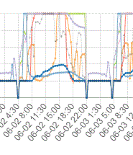

VAV SYS cooling coil power Mass flow rate CO2 Concentration

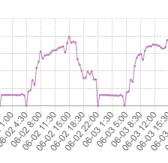 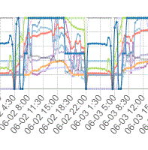 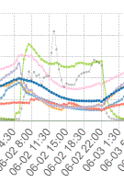

Reheat Coil Power

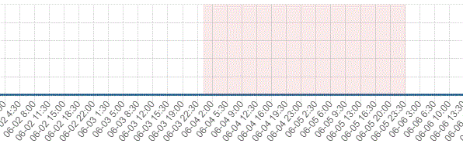

Light&Equipment Power, Temperature Data, VAV reheat damper position, VAV SYS cooling coil power, Mass flow rate, CO2 Concentration show a lot of fluctuations during weekday. However, the Reheat Coil Power shows 0 power through the period.

**Pattern 2)** Only two options in Light & Equipment power

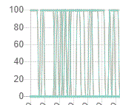

These sensors show only two levels of energy. It records 100% or 0%. This means it has the only two options to turn on and turn off.

**Pattern 3)** Repeated pattern during weekday

VAV Damper Position Mass Flow VAV SYS cooling Coil CO2 Concentration

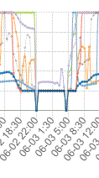 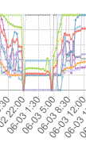 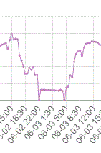 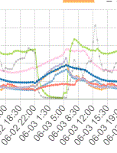

Temperature Data

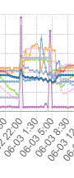

All of the graphs show a repeated pattern on every weekday’s 06:00~22:00 and 22:00 ~ next 06:00. VAV Reheat Damper Position, Mass Flow Rate, VAV SYS cooling Coil Power, CO2 Concentration go down at night. However, the temperature goes up at night, so we can guess that this is the summer period. In addition, the air conditioner is turned off at night.

**Pattern 4)** Stable & Regular temperature

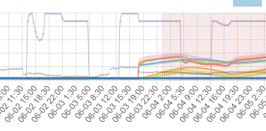

The supply inlet temperature shows quite a stable graph except anomalies pattern. But, the third floor supply inlet temperature shows some value on the weekend. This floor’s Supply Inlet Temperature stable and low in weekday, high stable in the weekend without zone1’s temperature.

**Pattern 5)** Peak value at midnight

VAV Reheat damper position Reheat Coil Power

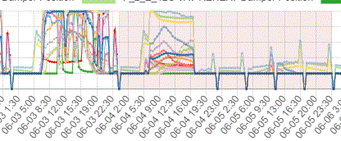 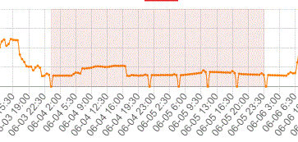

Supply Inlet Temperature Mass Flow Rate

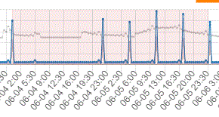 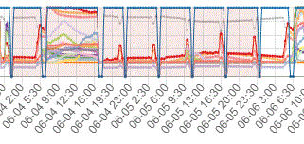

Temperature Data

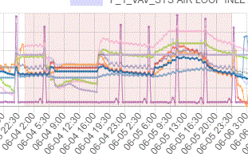

At the weekday’s midnight 00:00 some of the sensors show high peak or low peak. At the weekend those sensors show several high or low peak at Sat 22:00, Sun 4:30, Sun 11:00, Sun 17:30 and Mon 00:00.

**Q3. Five Notable Anomalies**

**Anomaly 1)** Some people visit the office during the weekend.

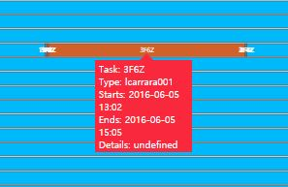 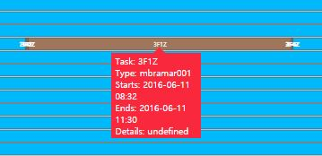

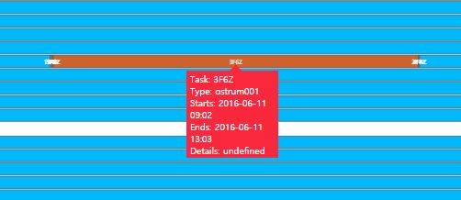

All the workers rest at the weekend. However, there are three people who visit during the weekend. Proxy ID of lcarrara, mbramar and ostrum are them. They are Carrara Lise from the Administration department, Bramar Mat from the Administration department and Strum Orhan from Executive department. They stayed for more than 2 hours in one place.

**Anomaly 2)** pyoung were two people??

We can find some reissued card. Most of them were not weird. But, pyoung001 shows weird pattern.

The above line is pyoung001 and the pointed line is pyoung002.

‘pyoung002’ was reissued at 06-02 morning. But pyoung001 is located in 2F4Z.

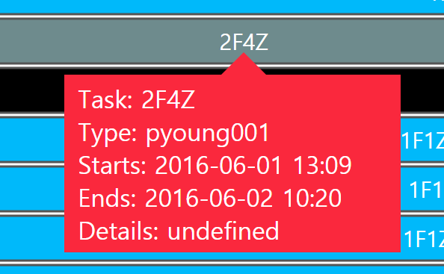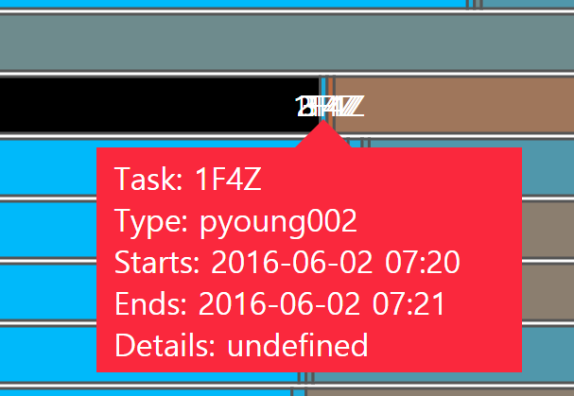

At some time, pyoung001 was started to move to a certain place which is the server room.

It was a very short time but there are some number of the same situation occurred in 06-02, 06-03, 06-08 and 06-10.

In our Visualization, the ‘Server Room’ tag observed only once. But, we suspected this situation by our visualization.

By seeing the detail data, we can notice all of the targets were server room.

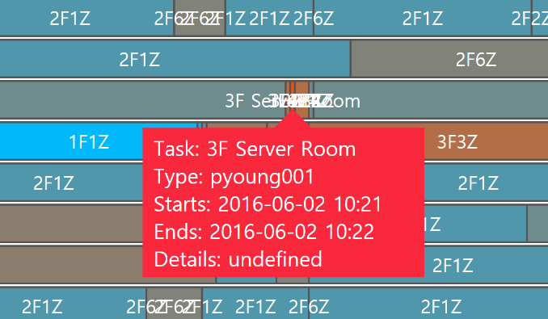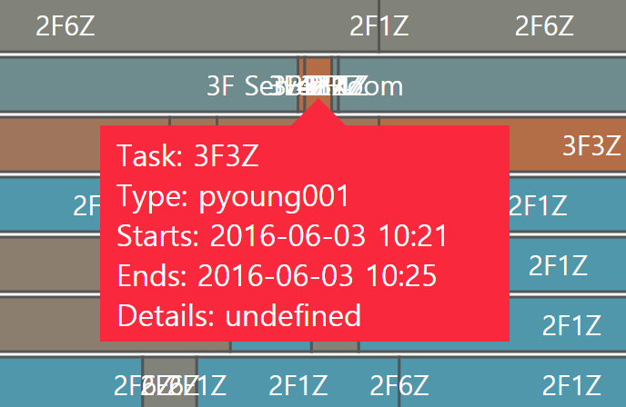

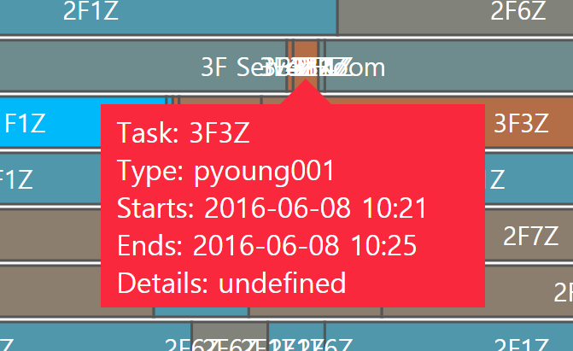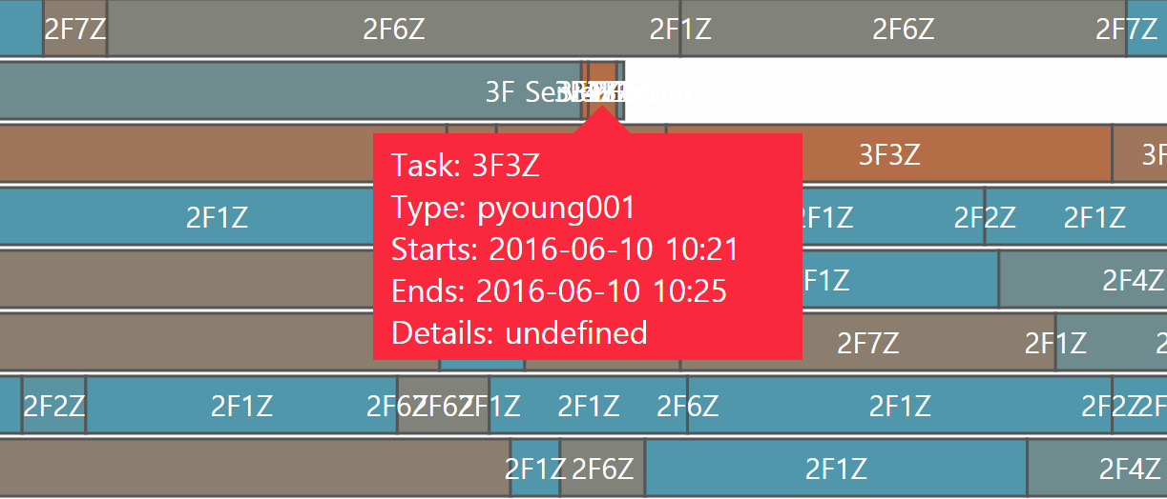

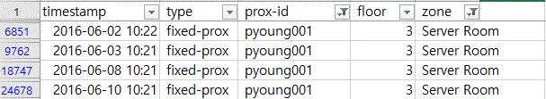

**Anomaly 3)** Lots of error on Tue 06-07 07:00 ~ 21:00 and Thr 06-08 07:00 ~ 21:00

There are issues with Temperature data, VAV Reheat Damper Position, Coil Power, Mass flow rate, CO2 Concentration, Supply Inlet Temperature. Those malfunctions are observed at the entire building. First of all, the cooling system represents the same level as the ordinary weekday’s night.

Problem Days Ordinary Day and Nighttime

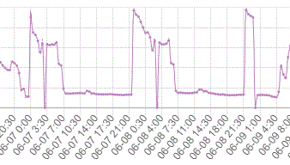 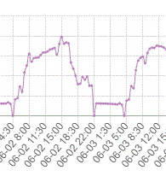

Also, the Reheat Coil power increases.

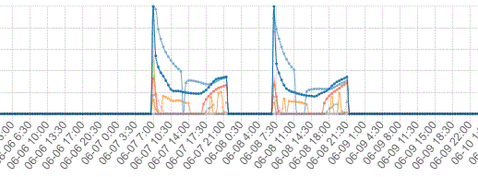

We can assume that it may cause some temperature issues in the building and the air conditioner and heater were flipped as we assume the problem has occurred that days. All temperature data, CO2 Concentration increase, and Damper Position shows low stable.

Also, the hazium level was increased 06-07.

Temperature Data Supply Inlet Temperature

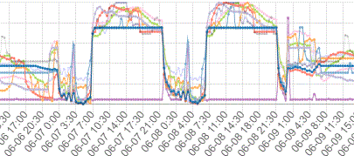 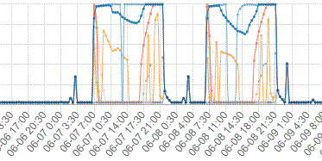

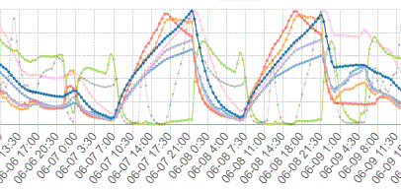CO2 Concentration Damper Position Data

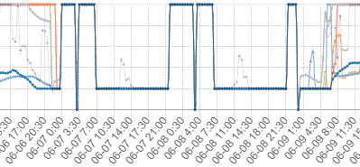

Hazium

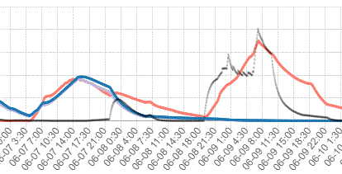

**Anomaly 4)** Weird peak 06-01 afternoon in floor1 and 3

Temp, heat coil, inlet temp record high peak at a certain time. In first-floor zone 2, at 06-01 13:00 to 14:30, there is a high peak of all temperature data and Reheat Coil.

Temperature Reheat Coil

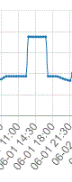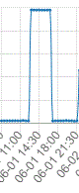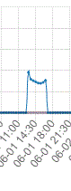

Also, in third-floor zone 5, at 06-01 13:00 to 14:30 there is a high peak of all temperature data and Reheat Coil.

Temperature Reheat Coil

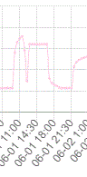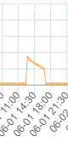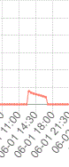

The Hazium Concentration in third-floor zone 1 has a peak at the same time.

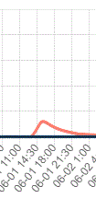

We suspect that it is a preliminary investigation of the case 06-07 and 06-08.

**Anomaly 5)** Anomalies at the second weekend

There are some anomalies in the second week period. There are anomalies with 1st and 2nd floor’s Coil power and inlet Temperature. In ordinary weekends, the Cooling Coil power level is low and the Reheat Coil power level is 0. However, both cooling power and heat power level is very high.

VAV SYS Cooling Power VAV Reheat Coil Power

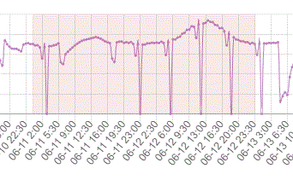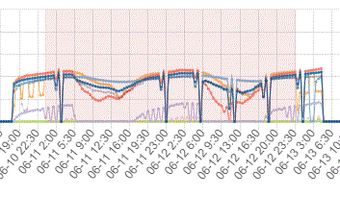

Also, supply Inlet Temperature level is high. This value maintains almost 0 in an ordinary case.

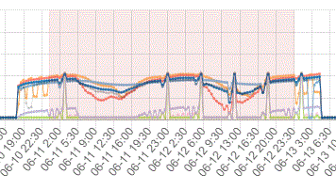

On that day the Hazium concentration sensor was recorded the highest value.

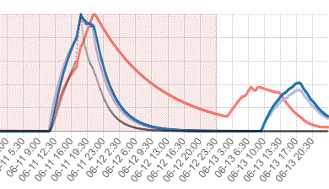

**Q4. Three Observed Relationships Between the Proximity Card Data & Building Data**

**Relationship 1)** Power usage dramatically drops during the weekend

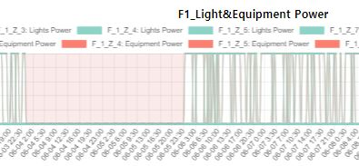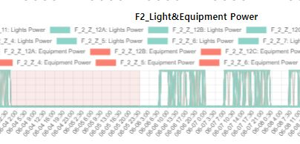

No workers on weekend

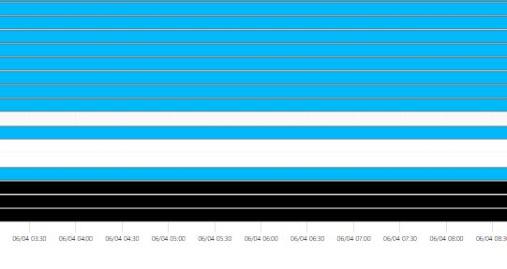

The pink area of the first two graphs represents the weekend. Since the employees of the company do not work on the weekend, no power is needed at that time. Thus, we can see that there is almost no power at the weekend.

**Relationship 2)** The reason for two pyoung.

We suspect the case of ‘Entered Unknown to Server Room’. So, we can find some relationship data time.

06-01 13:00, 06-02 10:00, 06-03 10:00, 06-08 10:00 and 06-10 10:00







The first time was stolen time. After that time the ‘pyoung001’ was not moved from 2F4Z.

At that time we can find anomalies of building sensors.



We can assume a scenario. Pyoung’s job is facilities. So, he found some anomalies and try to fix it. At that time he has stolen his ID card.

At 06-02 10:00 and 06-03 10:00, We couldn’t find anomalies on building sensor.

At 06-08 10:00, There was ‘the day of high temperature’ anomalies 3.

At 06-10 10:00, We can find anomalies which is the same situation with 06-01 13:00 case.

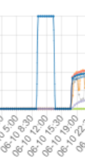

So, most of the anomalies caused by Those kinds of acts that smelled of crime.

**Relationship 3)** Hazium concentration surge right after leaving of Bramar Mat and Orhan Strum during the weekend. Also, Orhan Strum leaving rater.

Bramar Mat’s visit on the weekend



Orhan Strum’s visit on the weekend

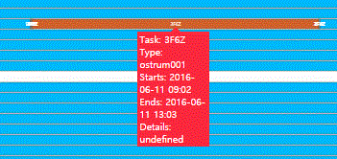

Hazium concentration

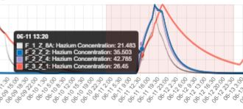

Abnormal visit of Bramar Mat was described at Question 3-1. When we compared this information with the building data, we figured out that Hazium concentration increases rapidly right after Bramar Mat left the building. We can infer that Bramar Mat might did something suspicious behavior during the visit.